**Assignment 9**

1. What are the different margins options and do we adjust the margins of the excel worksheet?

Answer: To use predefined margins, we can click **Normal**, **Wide**, or **Narrow**. Yes, we adjust the margins of the excel worksheet, to specify custom page margins, click Custom Margins and then in the **Top**, **Bottom**, **Left**, and **Right** boxes enter the margin sizes that you want.

2. Set a background for your table created.

Answer: Selected the worksheet then clicked on the **Page Layout tab** on the ribbon. Click on the **Background** next to the Breaks option in the **Page Setup** section. **Selected the picture to use for the sheet background from local computer, and then clicked Insert**.

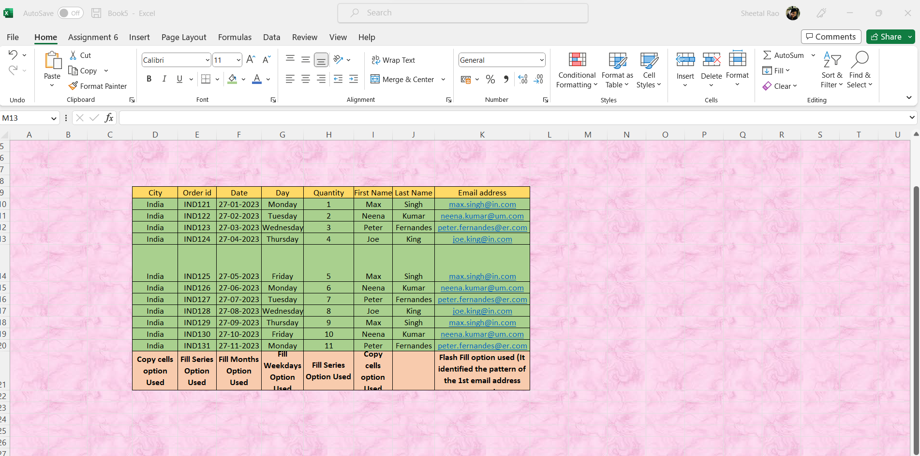

3. What is freeze panes and why do we use freeze panes? Give examples.

Answer: Freeze panes is a feature in spreadsheet applications that allows you to "lock" a row or column in place so that it is always displayed as you navigate around a [workbook](https://www.computerhope.com/jargon/w/workbook.htm). We use this feature to lock columns and/or rows so that when you scroll down or over to view the rest of your sheet, the column and/or row will remain on the screen.

**For example, to freeze the first three rows and the first three columns of a blank Excel worksheet, we undertake the following steps:**

* Select the cell D4.
* Click the “freeze panes” drop-down from the View tab of the Excel ribbon.
* Select the option “freeze panes.”

Rows 1, 2, and 3 and columns A, B, and C are frozen. Hence, by freezing panes, the user knows the kind of data contained in these fixed rows (1, 2, and 3) and columns (A, B, and C). Moreover, since these [rows and columns](https://www.wallstreetmojo.com/rows-and-columns-in-excel/) can be viewed at any point of time, one need not go back to them again and again.

Likewise, freezing excel panes can be applied to the row and column headers of a database. This allows one to constantly view the headings.

4. What are the different features available within the Freeze Panes

command?

Answer: There is **3 type** of Freeze Panes option available in View menu tab under Window section:

* **Freeze Panes**: It freezes the rows as well as the columns.
* **Freeze Top Row**: It freezes all the rows above the active cell.
* **Freeze First Column**: It freezes all the columns to the left of the active cell.

Freeze Panes is used to freeze the worksheet from the point where we keep our cursor. This freezes both the row and column both.

5. Explain what the different sheet options present in excel are and what

they do?

Answer: Sheet options present on the Excel ribbon and can be accessed by going to Page Layout > Sheet Options. It mainly has four toggle options: two for Gridlines and two for Headings, and they can be turned on and off by selecting and deselecting the checkboxes.

* **Gridlines**:
  + **View**: This option allows users to show/ hide gridlines within the active worksheet. Turning off this option removes the gridlines from the sheet and displays a blank Excel sheet.
  + **Print**: This option allows users to show/ hide gridlines on an Excel document that will be printed on paper.
* **Headings**:
  + **View**: This option allows users to show/ hide headings within the active worksheet. Turning off this option removes the headings from the current sheet's headers and footers.
  + **Print**: This option allows users to show/ hide headings on an Excel document, which is to be printed on paper.

After clicking on the 'More' option (the arrow icon on the corner of the Sheet Options group on the ribbon), we get various sheet options. These sheet options are mainly used to adjust preferences for printing purposes. For instance, when we print Excel documents, gridlines are not usually printed. We can adjust preferences from sheet options to include the gridlines to print and manage other sheet options.

* **Print Area**: We can select the print area using this option. We can drag and select the area or range of cells by using the mouse.
* **Print Titles:**
  + Rows to repeat at top: This option helps us select the title to display at the top for corresponding rows.
  + Columns to repeat at left: This option helps us select the title to display on the left side for columns.
* **Print:**
  + Gridlines: This option can be enabled or disabled by selecting/ deselecting the checkbox. It helps us decide whether to show gridlines or not on printed Excel documents.
  + Black & White: Like the gridlines, we can select this checkbox to print the current Excel document in black and white colour, even if we have the colour printer attached.
  + Draft Quality: Selecting the checkbox associated with the draft quality allows us to print the Excel document using the printer's draft-quality settings.
  + Rows & Column Heading: We can select this option to display rows and columns headings to the printed Excel documents.
* **Page Order:**
  + Down, then Over: This option allows users to print the down page first and then the right pages.
  + Over, then Down: This option allows users to print the right pages first and then the down pages.
* Print: Clicking on this option gives a command to the device to print the current Excel document using the default printer.
* Print Preview: This option displays the preview of the Excel document that will be printed on paper.
* Options: This option allows users to choose layout type (portrait or landscape) and paper mode (A4, A5, etc.) for the Excel document to be printed.